|  |  |
| --- | --- |
| Solar Chimney Experiment  Progressing Report | **ORIGINATOR:**  S3595897 Haoze Xia S3599541 Jarrod Lawson S3582207 Junxu Jin  **SUPERVISOR:**  DR Long Shi |

|  |  |
| --- | --- |
| **Section** | **Person(s) responsible and percentage** |
| (add, remove and rename sections as needed) | (e.g. Person A 70% Person B 20% Person C 10% OR All members contributed equally) |
| Summary | Junxu Jin 100% |
|
| Statement of problem | Junxu Jin 100% |
|
| Background and literature review | Jarrod Lawson 100% |
|
| Research questions | Junxu Jin 50% Jarrod Lawson 50% |
|
| Methodology | Haoze Xia 100% |
|
| Risk assessment and ethical considerations | Haoze Xia 100% |
|
| References | Jarrod 97% Junxu Jin 3% |
|
| Formatting and editing | Jarrod 70% Junxu Jin 15% Haoze Xia 15% |
|

**Group work member contribution table**

# Executive summary

4. Methodology and Engineering Design

4.1 Test rig and equipment utilized in the experiment

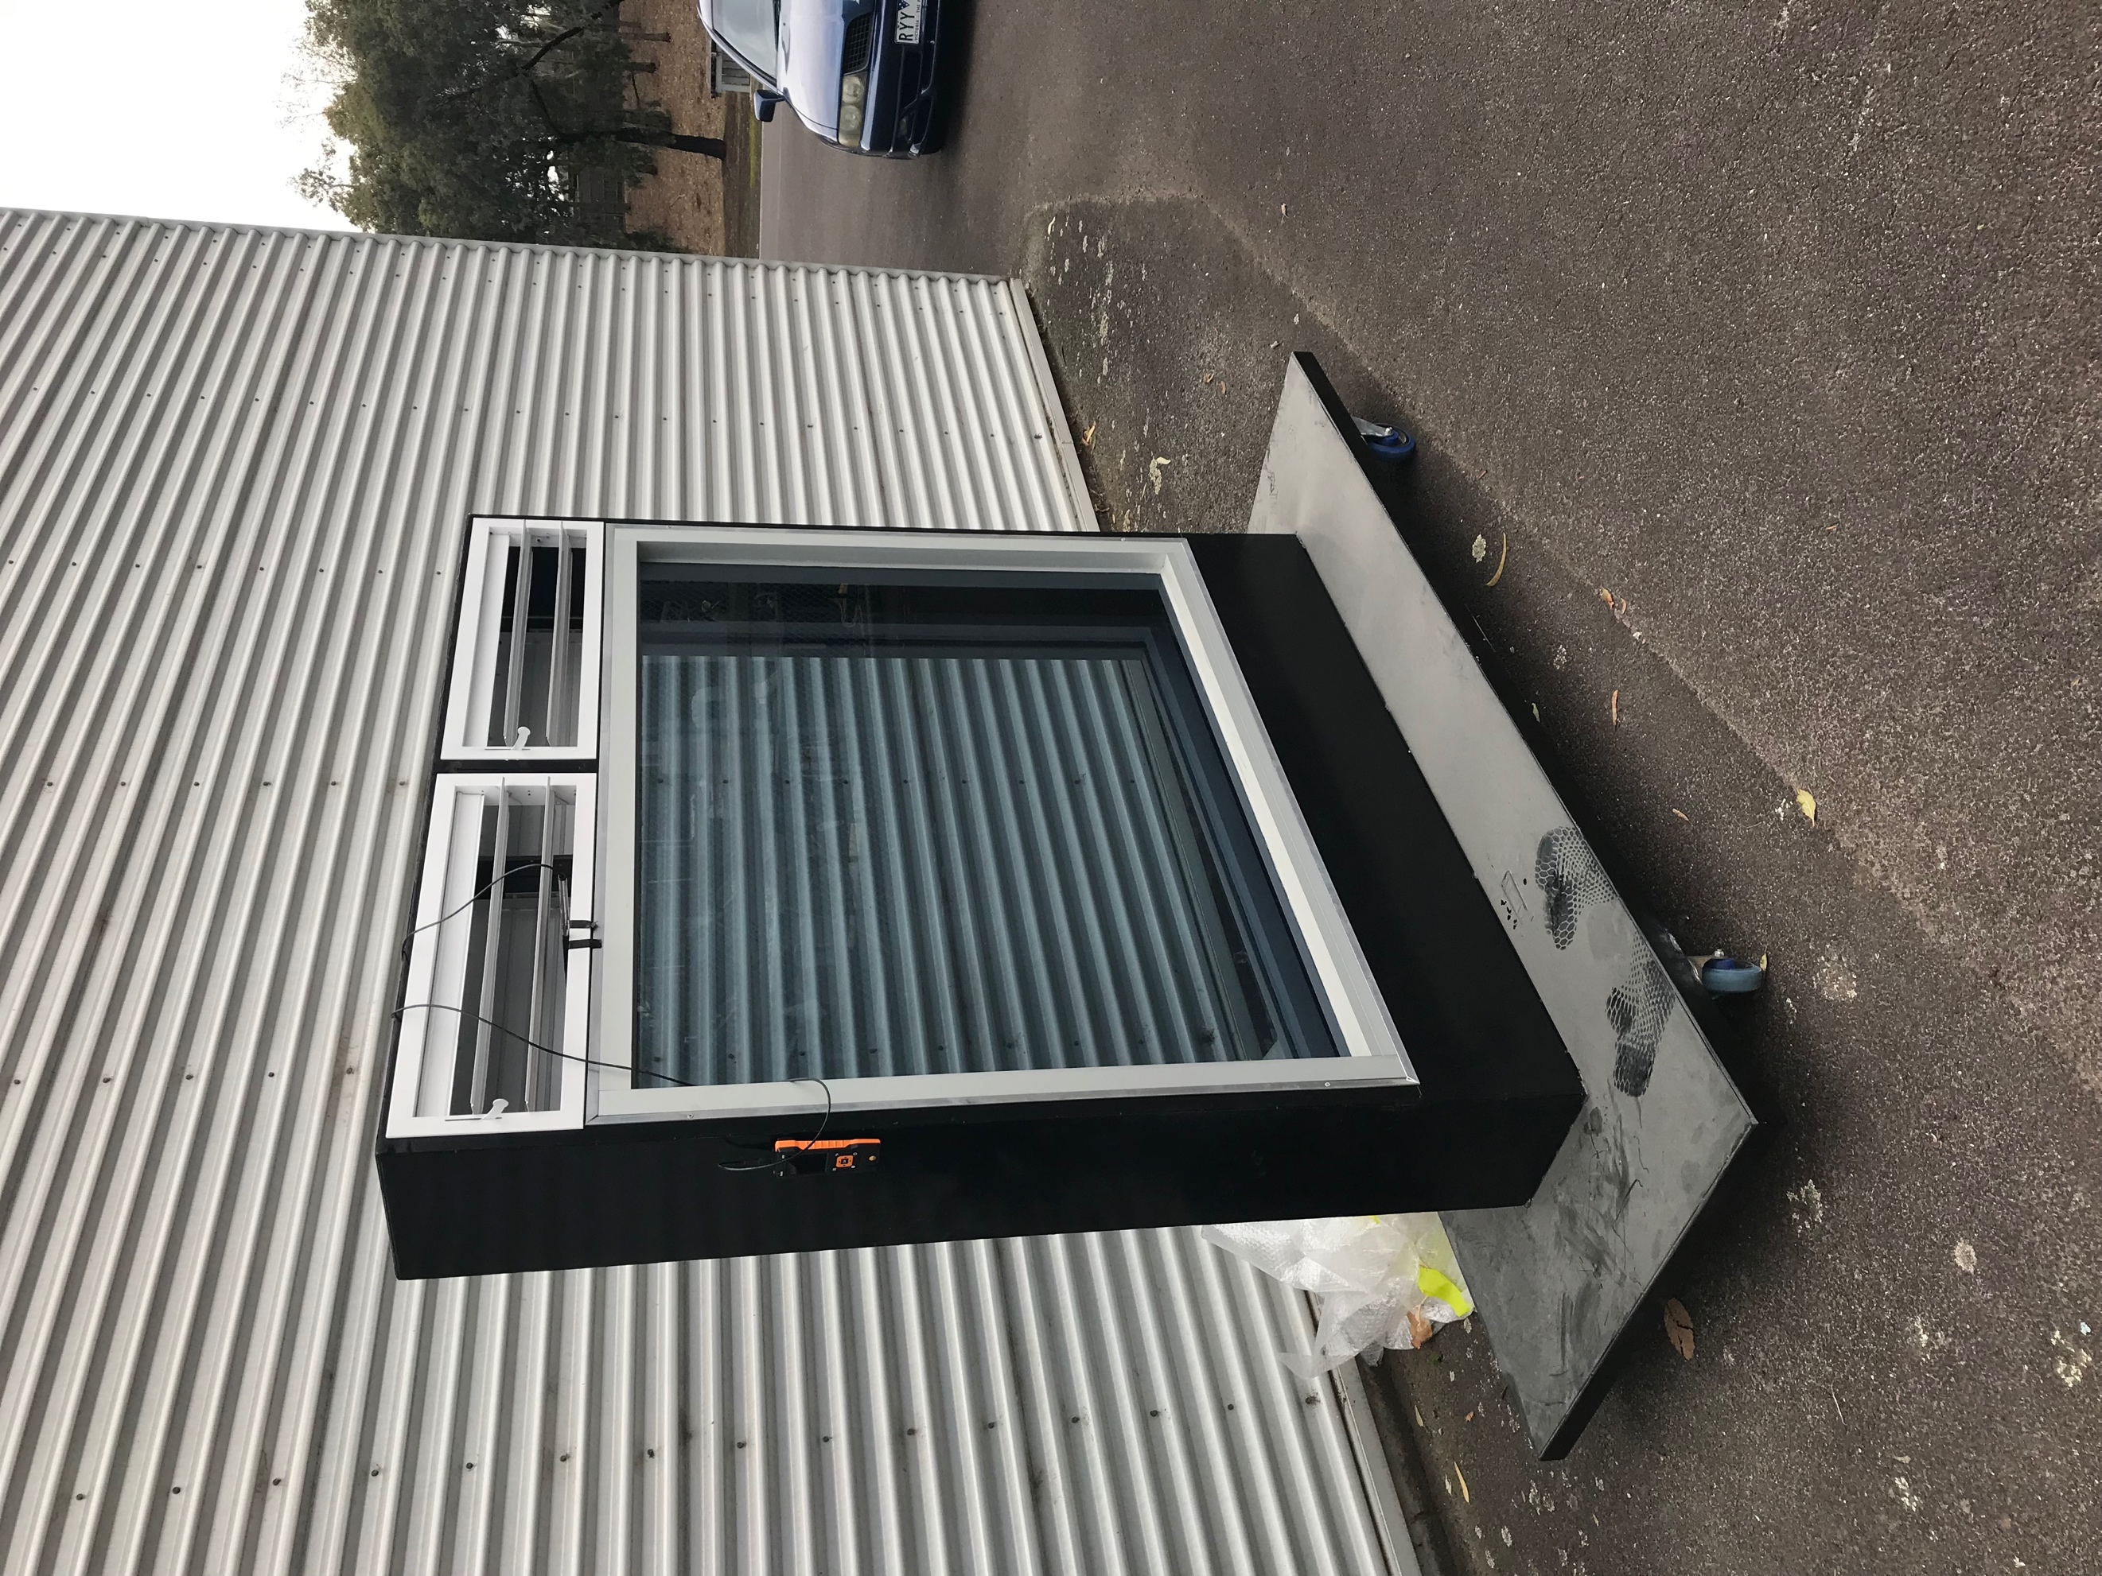The test rig used in the experiment is shown in Figure 4.1.1

Figure 4.1.1

The solar chimney used in the experiment is the Trombe wall type, and its length, width and height are (1600mm x 350mm x 1800mm). The solar chimney used in the experiment consisted of a metal material frame, plus two front and back glass, including a double-glazing low-emissivity glass and a single-glazing glass. The reason why double-glazing low-emissivity glass was chosen was because of prevention heat lost through convection and radiation. The solar chimney air inlet is designed in the experiment is installed under the double-glazing low-emissivity glass side, the air inlet/outlet as shown in Figure 4.1.2.

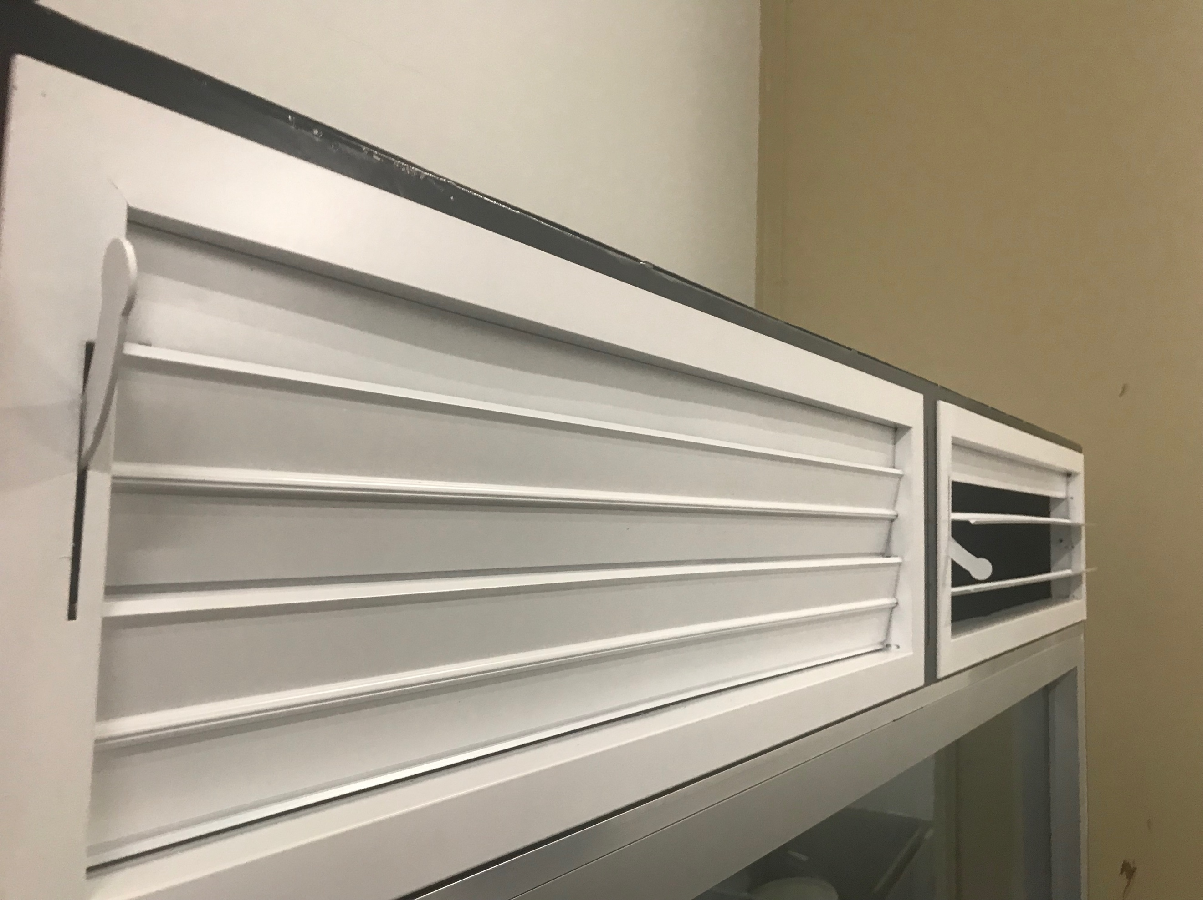

Figure 4.1.2

Each tuyere has two blades that can be adjusted from 0 to 90 degrees (reference with the vertical). The size of the air outlet is (750mm x 250mm). In the solar chimney used for the experiment, the air outlet is located above the glass on both sides, and each side has two air outlets. Each air outlet has two blades with the same structure as the lower air inlet. The reason why the air outlet is designed for both sides is because the solar chimney used for this test is of the Trombe wall type, which is installed in the house as shown in Figure 4.1.3.

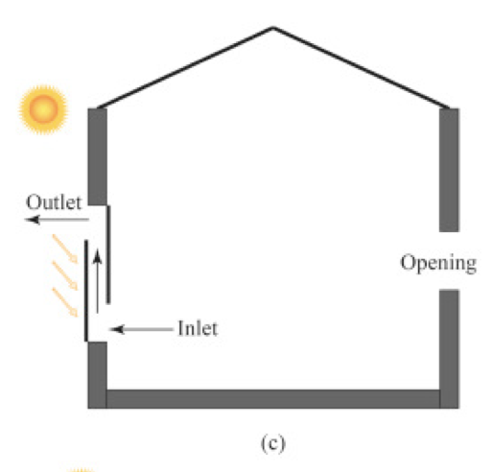Figure 4.1.3

The sun heats the air in the chimney by radiation. As the air is heated, the expansion density becomes smaller. Therefore, the air in the chimney moves upward through the air outlet, and then the air in the house flows into the chimney due to the difference in air pressure, forming a cycle. Speeding up the natural ventilation in the house can also reduce the electricity bills spent on cooling or heating in the house and reduce greenhouse gas emissions.

When the summer weather is hot, closed the air outlet of the solar chimney indoor side, open the air outlet outdoor side, and let the hot air inside the chimney be excluded.

When the winter is cold, open the air outlet of the indoor side of solar chimney, close the air outlet on the outdoor side, and let the hot air inside the chimney be discharged into the room to increase the indoor room temperature.

The instrument for measuring the air flow rate in the experiment is shown in Figure 4.1.4

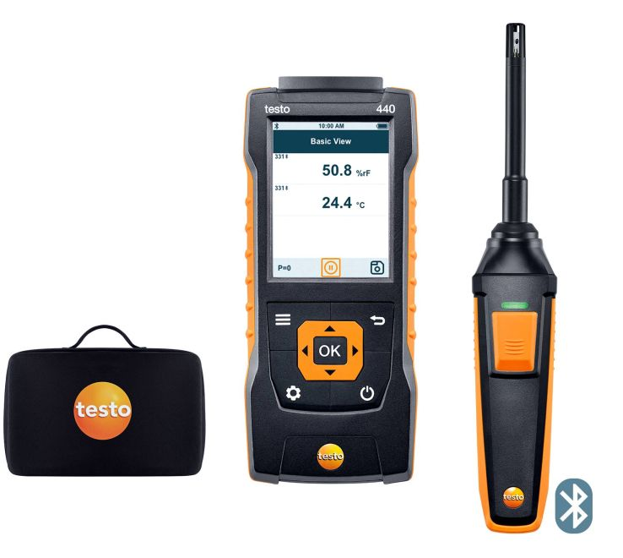

Figure 4.1.4

The instrument for testing air flow rate is Testo 440. This instrument has three parts. The first part is the wind speed and temperature tester for wireless Bluetooth connection, the second is the tester for wired wind speed and temperature, and the third part is data collection and setting portable host. This instrument can complete the recorded data autonomously according to the requirements.

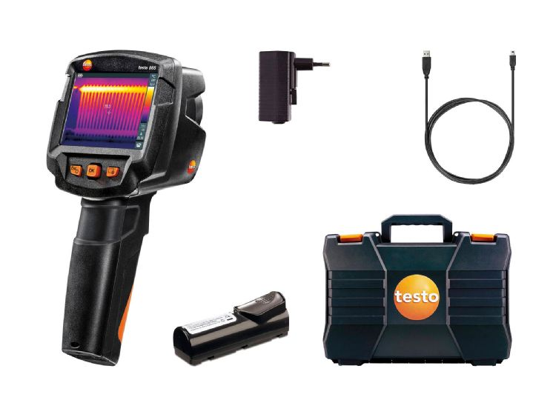The instrument for observing the heat distribution diagram in the experiment is shown in Figure 4.1.5

Figure 4.1.5

Observe the heat distribution of solar chimney is using the Testo 865. A handheld infrared camera with a battery that captures the radiation by the object itself to determine the temperature and present it as an image.

The instrument for measuring the temperature inside the solar chimney in the experiment is shown in Figure 4.1.6

Figure 4.1.6

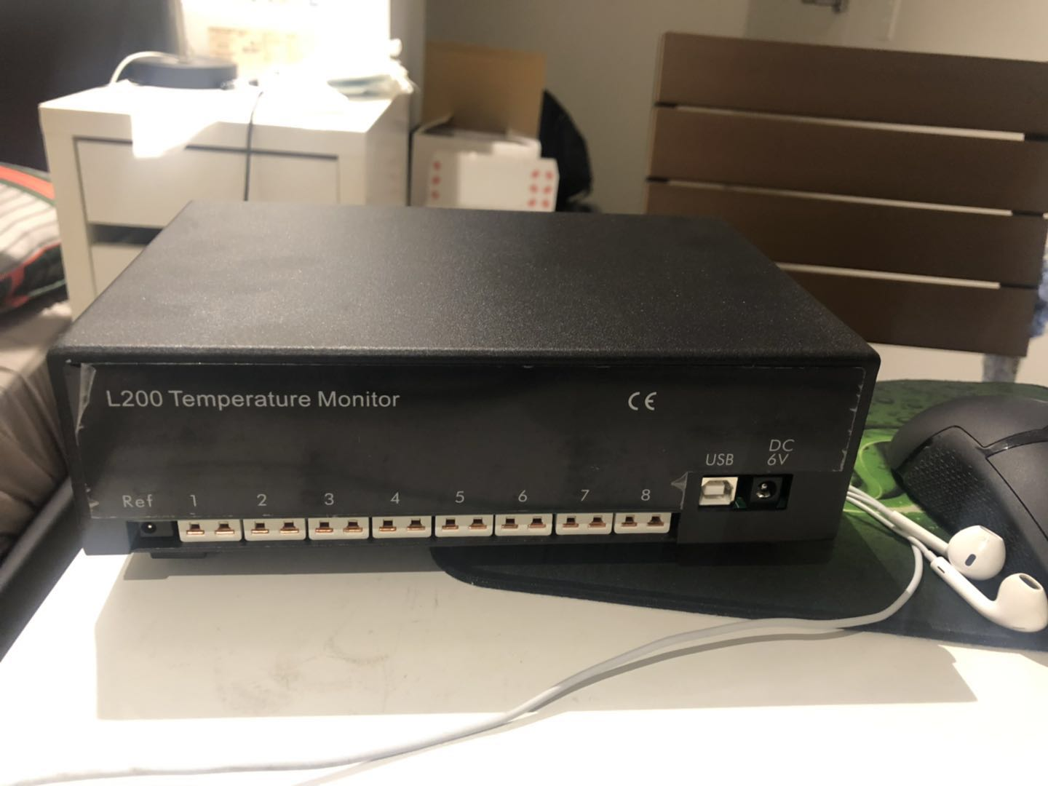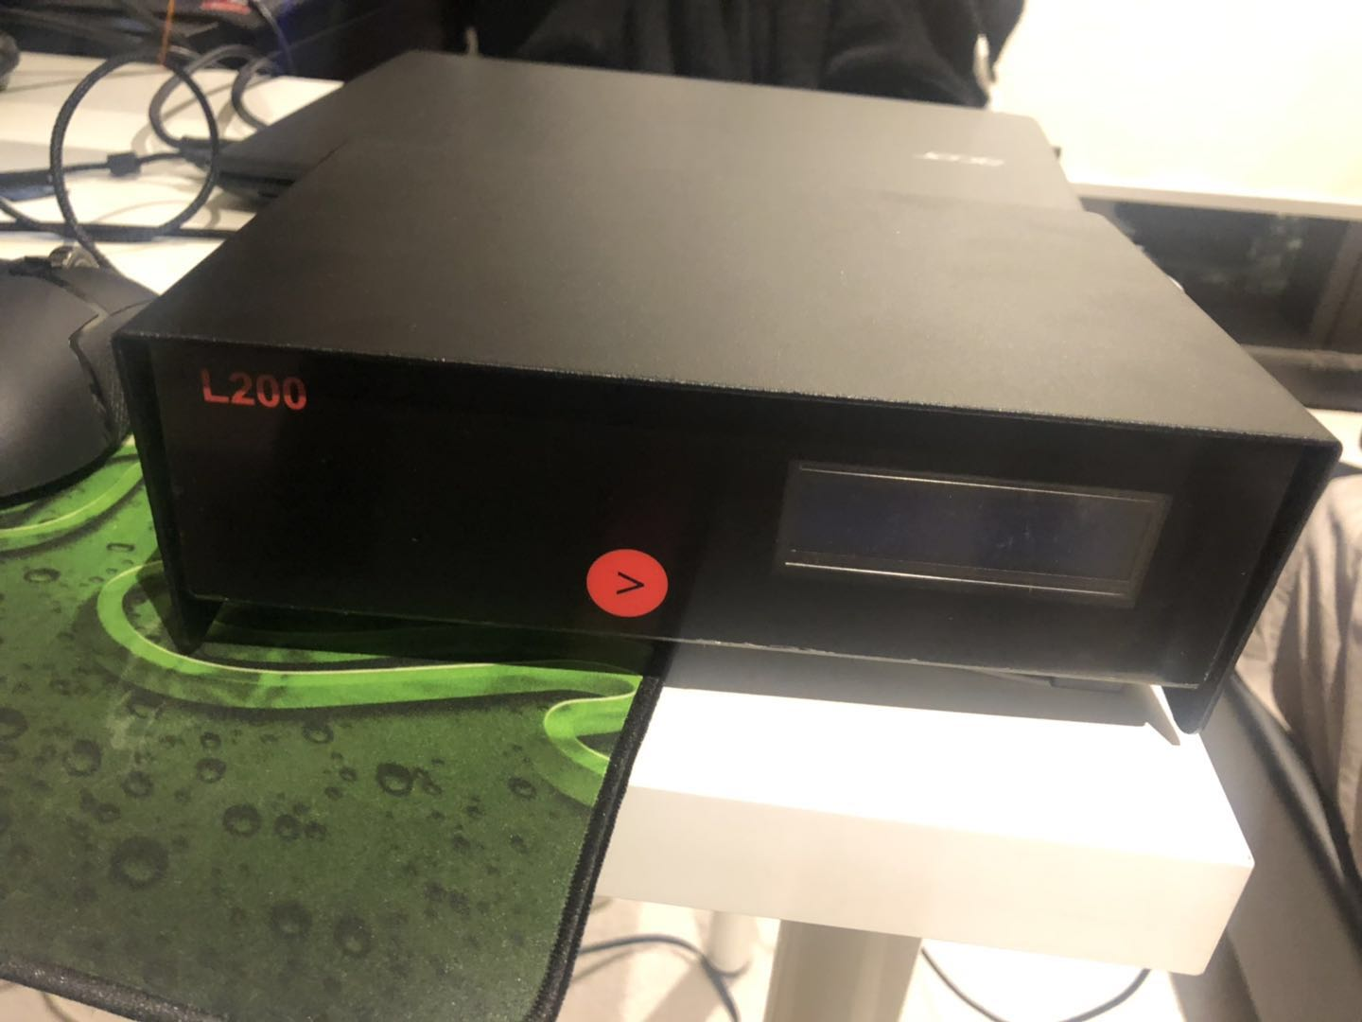

The instrument used to measure the temperature inside the chimney is the thermocouple L200 Temperature Monitor, which has eight temperature measurement ports, and can separately record the temperature at different points of time through software.

Safety instruction:

In order to ensure the safety of personnel according to the safety of RMIT laboratory, steel cup shoes and PEE clothes should be properly worn.

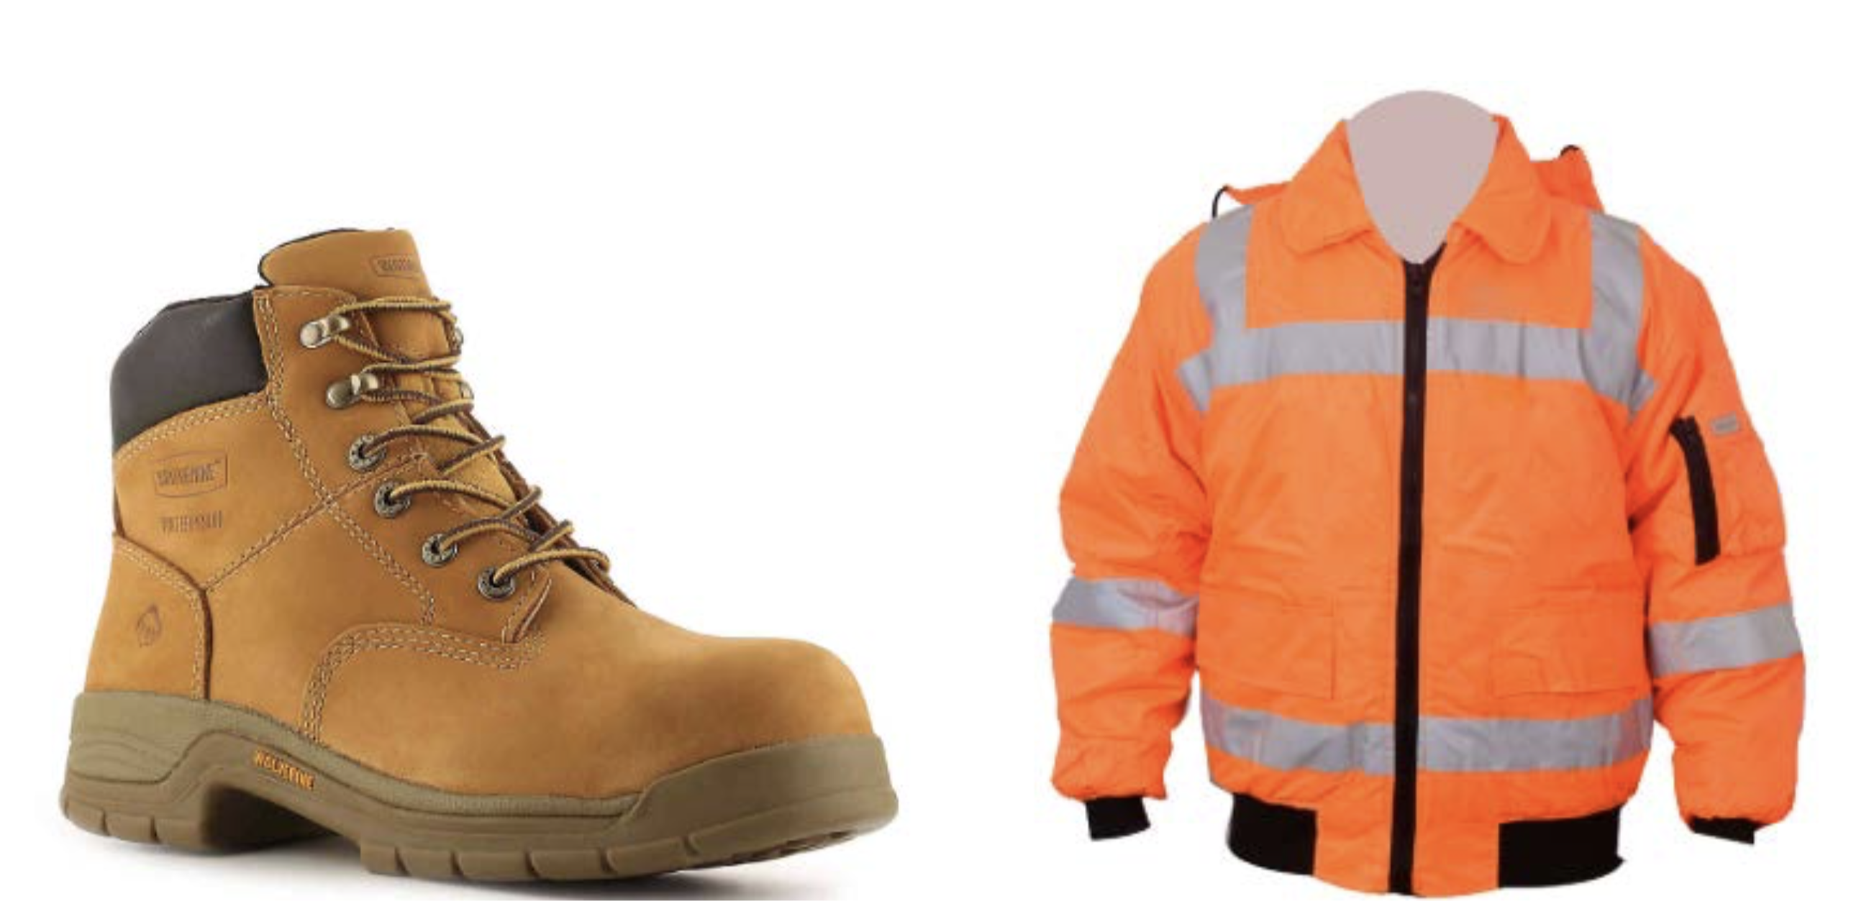Figure 4.1.7

4.2 The Engineering Design in the Experiment

The goal of Capstone A is to design the experimental steps, use the instrument correctly and accurately record the data to be measured. Initial tests can prove that our experimental procedures and testing of the solar chimney model are correct.

The experiment location is in RMIT Bundoora East Campus

The way to use Testo 440 is as follow:

Connect the tester (Wired, Bluetooth) to the host, set the time for 30 minutes, record the wind speed and temperature every five seconds. The placement position is shown in Figure 4.2.1:

Figure 4.2.1(Left Air inlet, Right Air outlet)

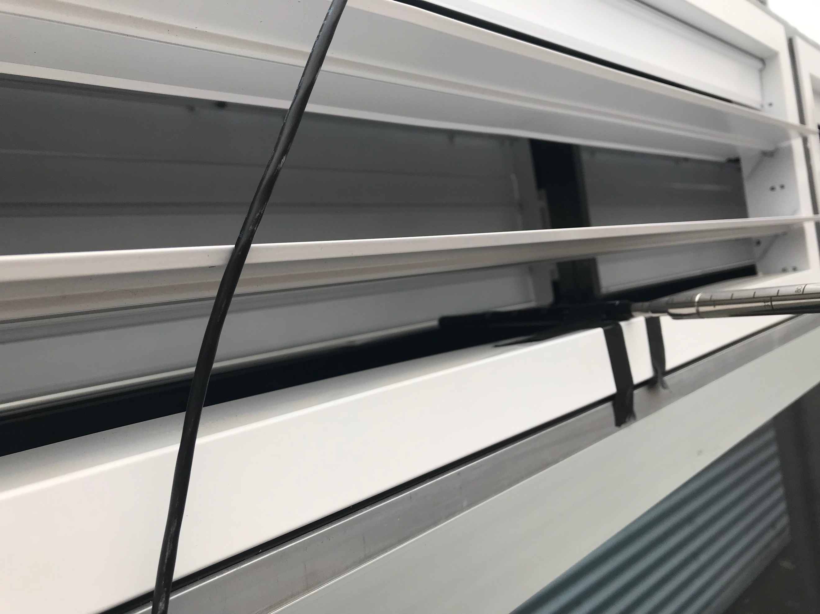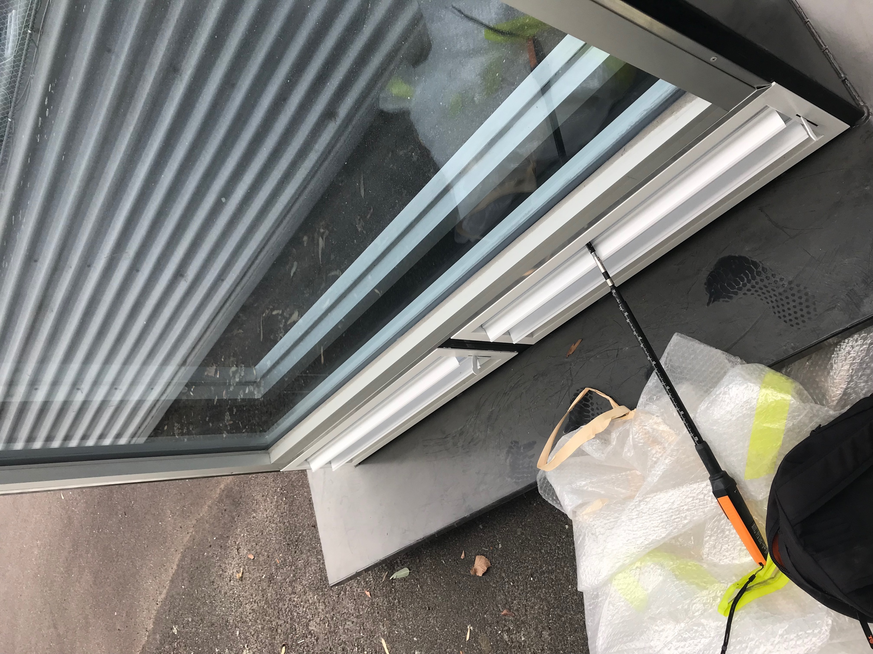

The way to use Testo 865 is as follows:

Point the infrared camera at the solar chimney and take it every five minutes.

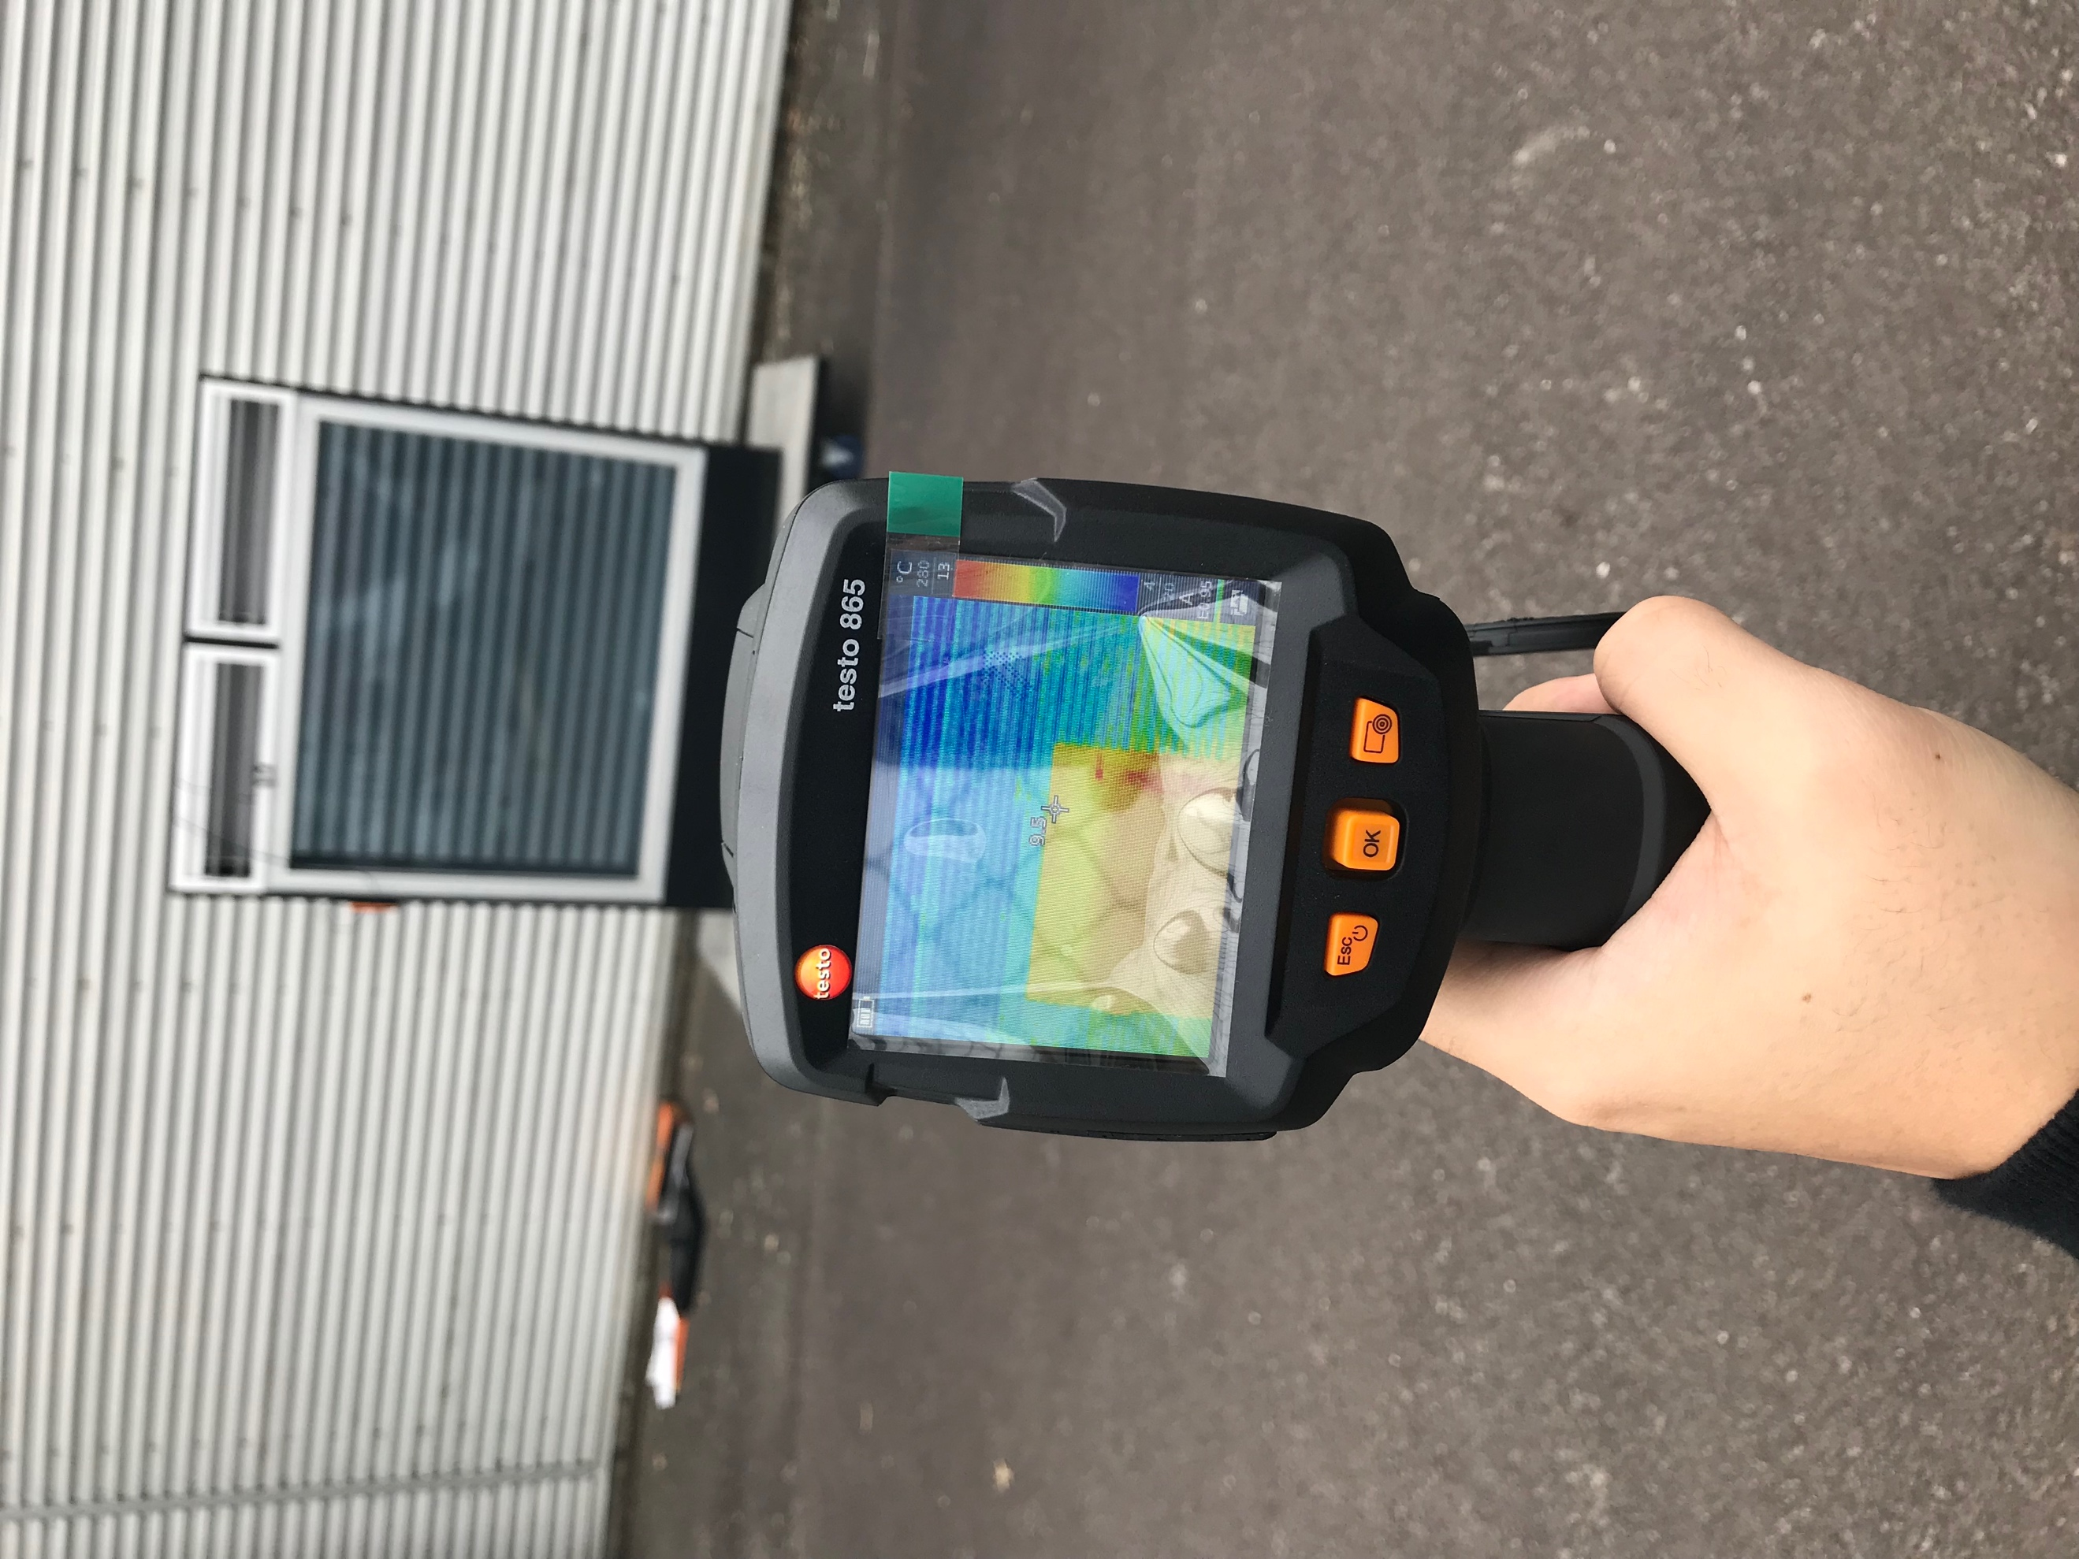

Figure 4.2.2

The way to use the L200 Temperature Monitor is as follows:

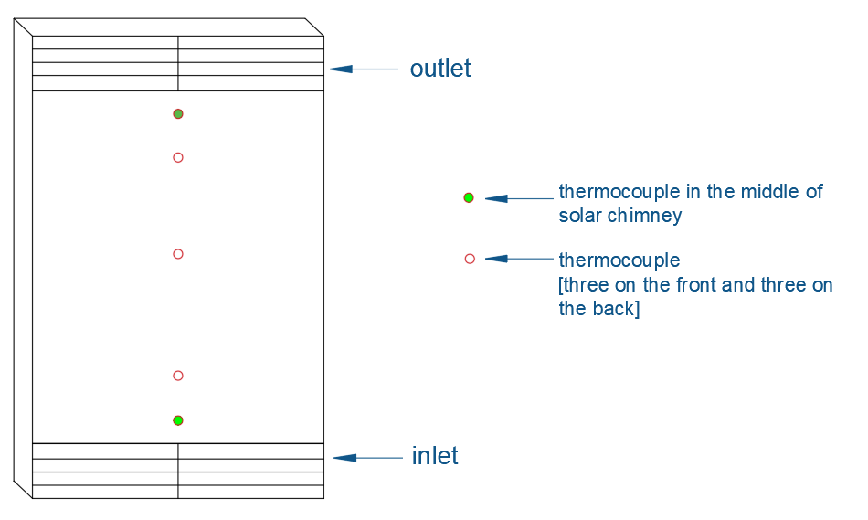

Figure 4.2.3

Place the eight thermocouples in the position shown in Figure 4.2.3. Place the three thermocouples evenly on the single-glazing glass. Place the three thermocouples evenly on the double-glazing glass. Place one thermocouple in the upper and lower center positions of the solar chimney.

Data such as solar radiation intensity, ambient temperature, wind speed, etc. can be collected from the weather station in RMIT Bundoora East Campus Building 258, and the weather station records data per minute.

4.3 Testing Steps and Analysis methods in the experiment

Experiment Procedure:

1. The single-glazing surface of the solar chimney faces the north, and the double-glazing surface faces the wall.

2. Install the thermocouple evenly on the heated wall.

3. Place the Testo440 in the air outlet and air inlet.

4. Adjust the blade angle of the air outlet and the air inlet.

5. Wait for the solar chimney to warm up, until the data is stable.

6. Start recording data [outlet air flow rate, inlet air flow rate, heated wall temperature, solar radiation intensity, ambient temperature] recorded every 5 seconds, infrared camera record every 5 mins and a total of 1 hour of data needs to record.

7. Adjust the blade angle of the air outlet and the air inlet to the next position, repeat step 6.

Experimental data table:

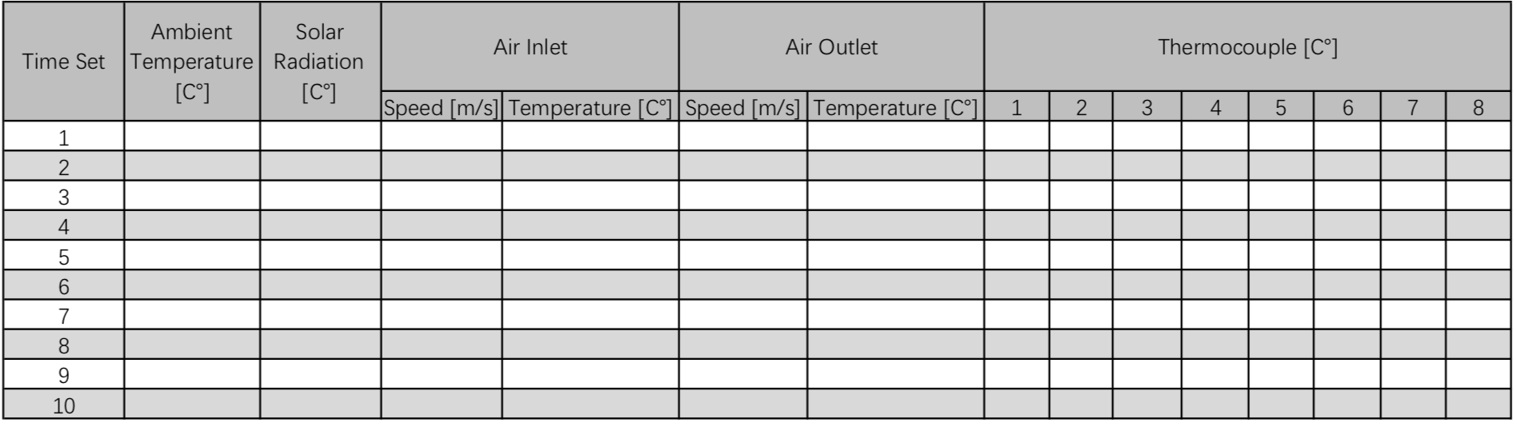

Table 4.3

6. Preliminary Finding

There are many problems in the actual experiment, which leads to the inaccuracy of the experimental data, resulting in insufficient time and only one set of experiments.

* Problem 1: Because the temperature-measured thermocouple requires a power connection, the test solar chimney is outdoors, there is no power cord to connect, so the Work Shop is required to provide an extension cable, but because the risk assessment does not meet the requirements, the experiment is delayed.
* Problem 2: Because when we determined the experimental steps and the use of measuring instruments, Melbourne has entered the winter, the winter sunshine time is short, the temperature is low and windy day, it was raining on the day we determined the test time, the following ten days the weather is rainy and rainy, which has led to inaccurate experimental data.
* Problem 3: Because this is a group experiment, but the time that everyone can do the experiment together is not that much, and one person can't complete the experiment, so the experiment only completed one group.
* Question 4: Because the data collected by the weather station is in Building 258, we don't have the key, so we have to go to the work shop to find someone to open the door for us.

Experiment Data Analysis:

At 10 o'clock on the morning of 28/05/2019, we started our experiment. Junxu Jin did not participate in this experiment because of illness, so the thermocouple he was responsible for was not used in this experiment. The weather is cloudy, the test time is 30 minutes, the solar chimney is warmed up for 10 minutes, the temperature and wind speed are recorded every 5 seconds by Testo 440, Testo 865 takes a temperature profile of the solar chimney every five minutes, and the weather station records the weather data every minute (ambient temperature, ambient temperature)

The specific experimental data is as follows:

Figure 6.1

Figure 6.2

Figure 6.3

Figure 6.4

|  |  |  |  |  |
| --- | --- | --- | --- | --- |
|  | Outlet | | Inlet | |
| Speed [m/s] | Temperature [℃] | Speed [m/s] | Temperature [℃] |
| Mean | 0.02 | 11.4 | 0.02 | 11.7 |
| Max | 0.14 | 11.9 | 0.14 | 12.3 |
| Min | 0 | 11.3 | -0.02 | 11.5 |

Table 6.1

The above data is recorded by Testo 440. It can be seen from Figure 6.1 that the negative speed may be caused by the ambient wind on the test day, or it may be affected by the position of the tester. The maximum speed is found to be 0.14m/s. It may be because the weather is cloudy and the solar radiation intensity is not high, so solar chimney does not really work. From Figure 6.2, the air outlet in the chimney is not high, which may be due to the position of the tester. The maximum wind speed of the air outlet is also 0.14m/s. From Figure 6.3 and Figure 6.4, the temperature is higher at beginning and then lowers and stabilizes. The average temperature of the air inlet is higher than the air outlet.

Figure 6.5

Figure 6.6

Figure 6.7

|  |  |  |  |
| --- | --- | --- | --- |
|  | Ambient Temperature | Wind Speed | Solar Radiation |
| [℃] | [m/s] | [W/m^2] |
| Mean | 10.07 | 6.83 | 134.27 |
| Max | 10.3 | 9.7 | 151 |
| Min | 9.8 | 3.2 | 97 |

Table 6.2

The above data comes from weather station

According to Figure 6.5, it is found that the solar radiation is relatively stable and there is no large fluctuation, but the average solar radiation is 134 w/m^2 under the influence of winter cloudy weather. Figure 6.6 shows that the temperature gradually rises with time, but this is in contrast to Figure 6.3 and Figure 6.4, so it is more certain that there may be problems with the tester placement of the Testo 440. It can be seen from Figure 6.7 that the wind speed of the day is still affecting our experiment.

Solar chimney temperature distribution graph:

Figure 6.8

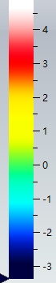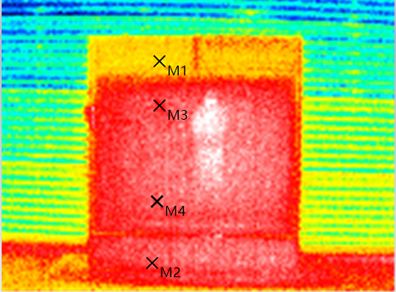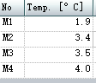

T=10 mins

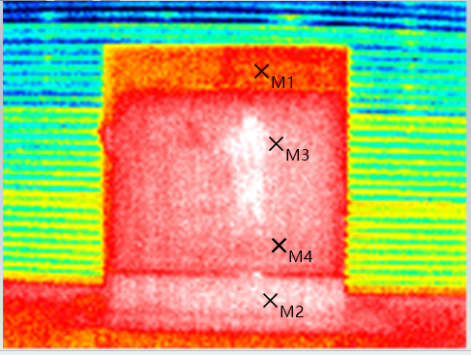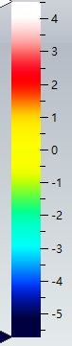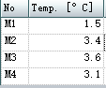

T=15 mins

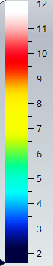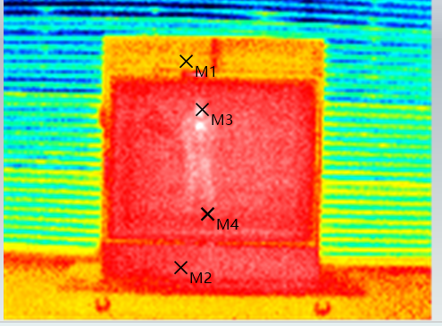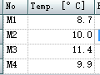

T=0 min

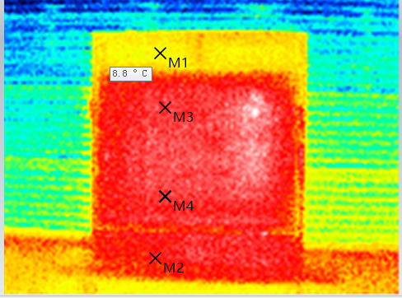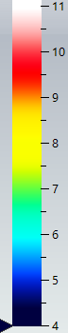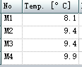

T=5 mins

Figure 6.9

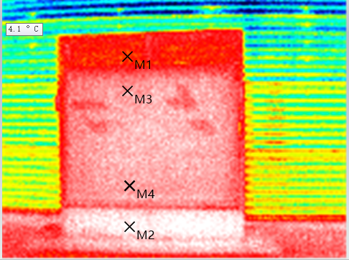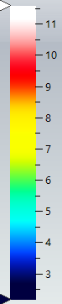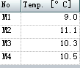

T=20 mins

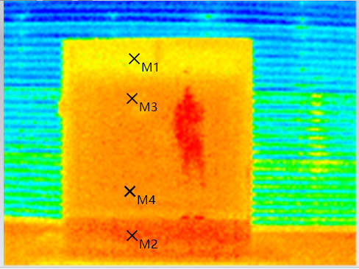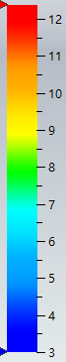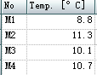

T=25 mins

Figure 6.10

As can be seen from the above figure, the solar chimney of this experiment did not work normally, M1 point is the air outlet, M2 is made of metal material for the back side of the air inlet, M3 is single glazing near the air outlet, M4 is close to the air inlet. The temperature of M1 is generally lower than M2. It may be caused by different materials. The material at M2 is also more endothermic than the white blade at M1. The temperature of the solar chimney M3 under normal working conditions should be higher than the temperature at M4. At T=0 min and T=15 mins, the temperature at M3 is higher than M4, indicating that the solar chimney is in normal working state at this time.

Based on the above analysis, we will improve the above problems in Capstone B.

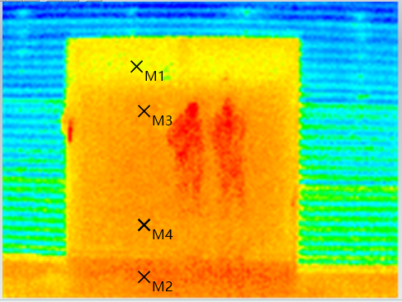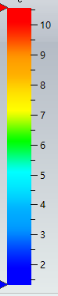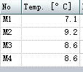

T=30 mins

7. Project management and timeline

7.1The timeline planning and timeline in practice

* The green colour: Design and Preparing the Experiment
* The yellow colour: Analysis and Conduct the Experiment
* The red colour: Report and Finalize the Experiment Report

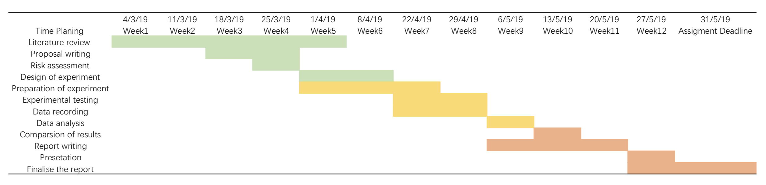Gantt Chart for Timeline Planning

Figure 7.1.1

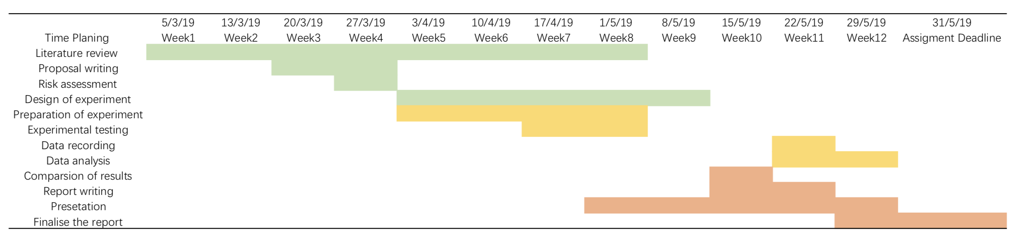Gantt Chart for Time in Practice

Figure 7.1.2

Project Management:

|  |  |  |  |  |
| --- | --- | --- | --- | --- |
| Priority | Deadline | Task | Assignee | % Done |
| Low |  | Literature Review | Haoze Xia, Junxu Jin, Jarrod Lawson | 100 |
| High | Week 4 | Risk Assessment writing | Haoze Xia, Junxu Jin, Jarrod Lawson | 100 |
| Low | Week 4 | Proposal Writing | Haoze Xia, Junxu Jin, Jarrod Lawson | 100 |
| High | Week 8 | Design of Experiment steps | Haoze Xia, Junxu Jin, Jarrod Lawson | 100 |
| High | Week 8 | Preparation of experiment source | Haoze Xia, Junxu Jin, Jarrod Lawson | 100 |
| High | Week 12 | Experiment testing | Haoze Xia, Junxu Jin, Jarrod Lawson | 100 |
| Low | Week 12 | Data Record | Haoze Xia, Junxu Jin, Jarrod Lawson | 50 |
| Low | Week 12 | Data analysis | Haoze Xia, Junxu Jin, Jarrod Lawson | 50 |
| High | Week 12 | Comparison of results | Haoze Xia, Junxu Jin, Jarrod Lawson | 50 |
| High | Week 12 | Progressing Report writing | Haoze Xia, Junxu Jin, Jarrod Lawson | 100 |
| Low | Week 12 | Presentation | Haoze Xia, Junxu Jin, Jarrod Lawson | 100 |
| Low | Week 12 | Summary pf the project | Haoze Xia, Junxu Jin, Jarrod Lawson | 0 |